PRE-REQUISITES

# Install Anaconda

|  |  |
| --- | --- |
| Team ID | PNT2022TMID08090 |
| Project Name | University Admit Eligibility Predictor |

Anaconda is a distribution of the Python and R programming languages for scientific computing that aims to simplify package management and deployment. The distribution includes data-science packages suitable for Windows, Linux, and macOS. It is developed and maintained by Anaconda, which was founded by Peter Wang and Travis Oliphant in 2012 as Anaconda.

# INSTALLING ANACONDA

**Step 1 :** Download Anaconda Installer from <https://www.anaconda.com/products/distribution>

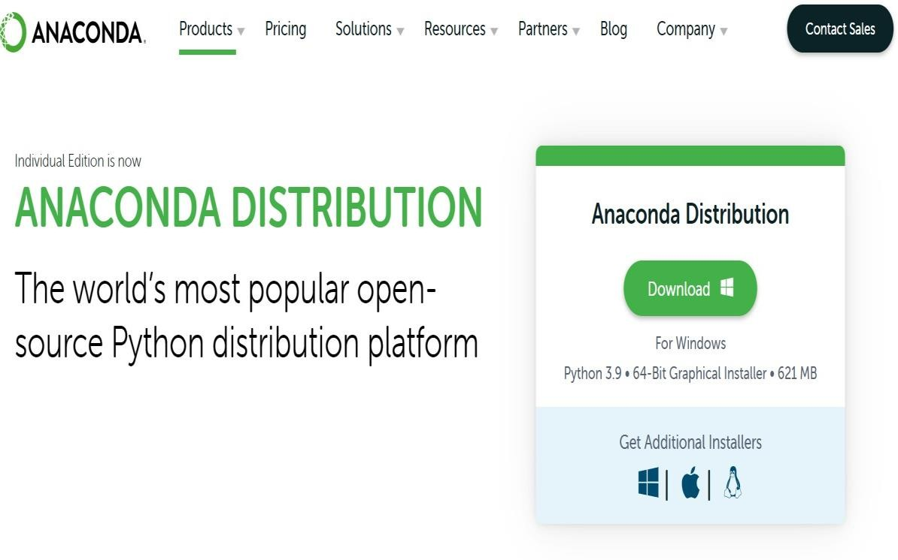

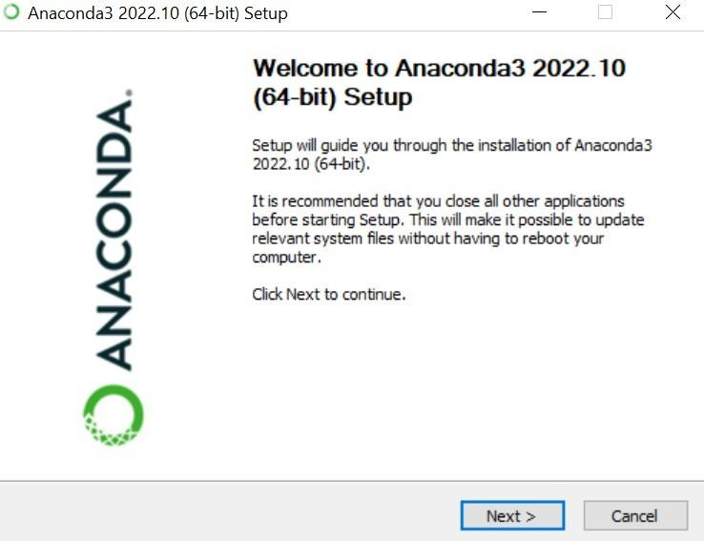

**Step 3 :** Click I Agree to accept the terms and Conditions

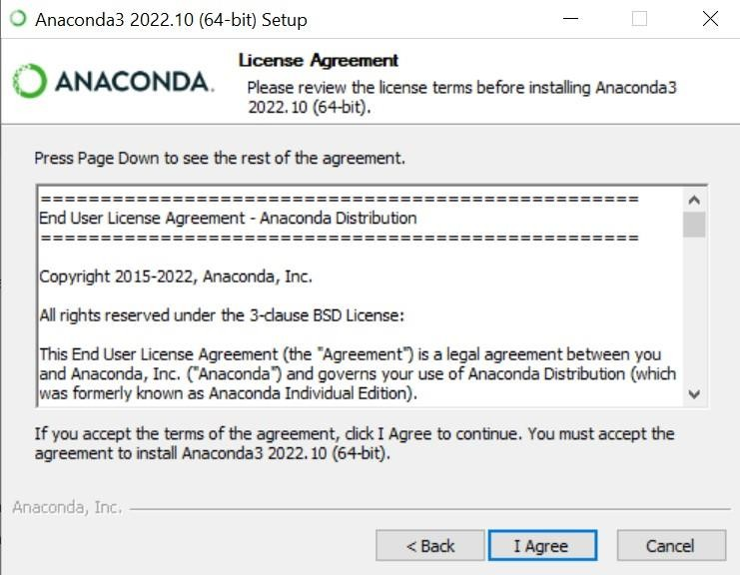

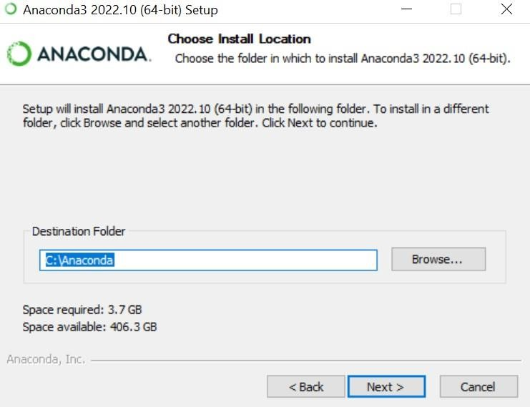

**Step 5 :** Installing the Required Packages

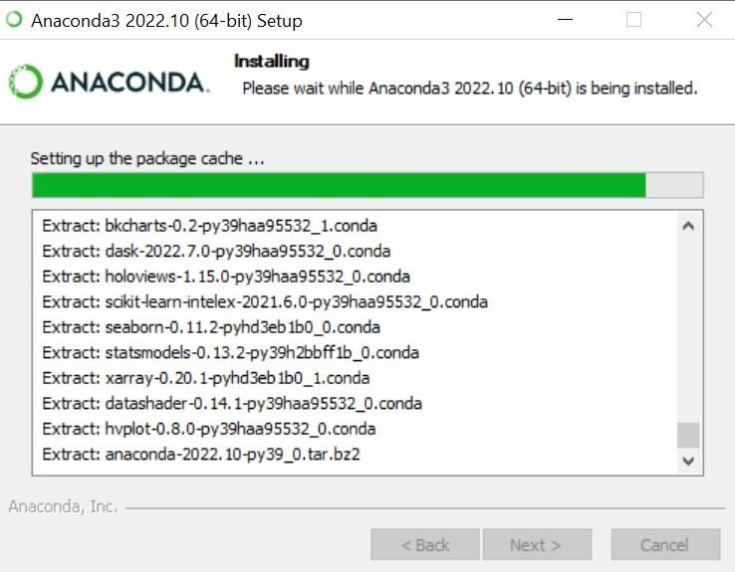

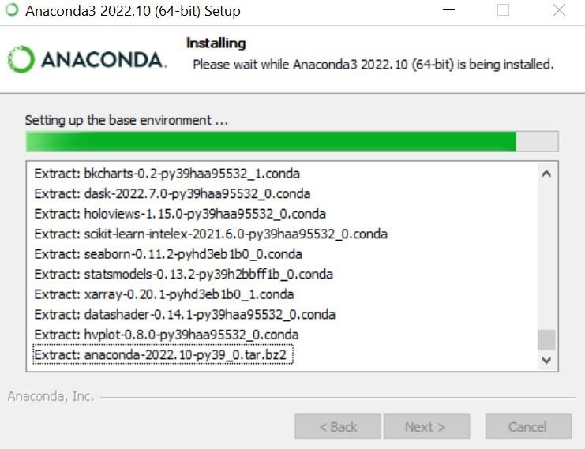

**Step 7 :** Open Anaconda Navigator and check whether it works.

